Intro to Vehicle Performance – Notes[1]

# 2. Intro. to Keplerian Orbits and the Two-Body Problems (Part 1)

## Some Mathematical Notations

* **Position vector:**
* **Magnitude/Norm of position vector:**
* **Velocity vector:**
* **Acceleration Vector:**
* **Unit vector:**

## Newton’s Law of Universal Attraction

* A point mass M attracts another point mass m by a force directed along the line intersecting both points
  + The force is proportional to the product of the two masses and inversely proportional to the square of the distance between the two point masses

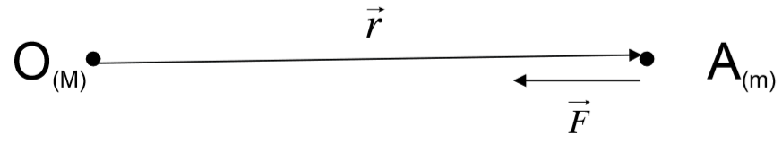

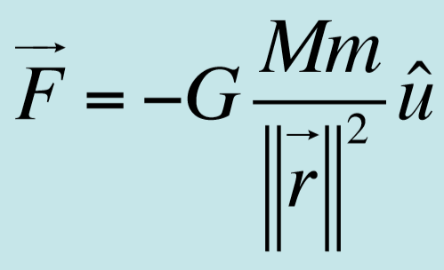

* + G is the universal constant of gravitation
  + “: attracts”
* Calculate the gravitation forces on Earth by the sun and other planets:

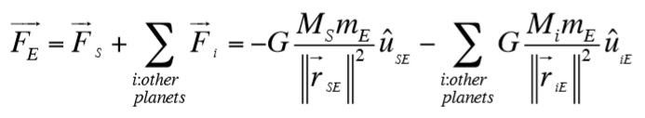

## Setting up the N-Body Problem

* Consider n objects of mass ni (i = 1 … n)
* 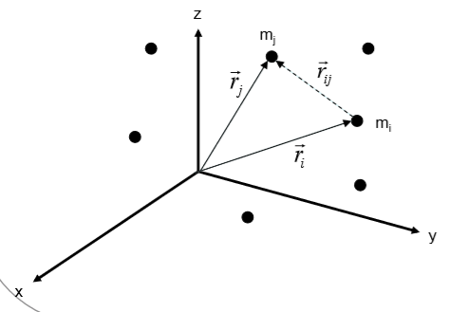Each mass position vector with respect to an inertial reference frame is:
* The vector pointing from mi to mj is:
* The unit vector between mi to mj can be written as:
* **The n-body problem:** The n masses are only subject to their mutual attractions (gravity).
  + Determine their motion with respect to the inertial frame, so find:

for to

* According to Newton’s law of universal gravitation, mass mj is subject to all the attraction forces exercised by the other masses:

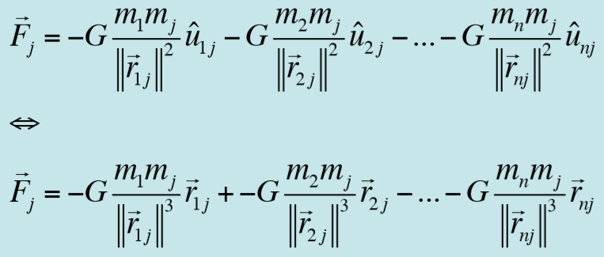

* + Which we can write as:

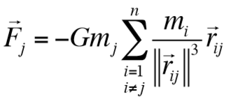

* + Then, if we bring in Newton’s second law of motion (F = ma):

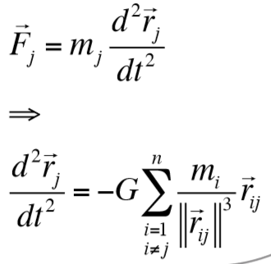

* “We can similarly express the differential equation for the position vector of each mass” (ok but how exactly?)
  + So we get a **system of n differential equations**
  + We **need 2n initial conditions** to get a complete mathematical description of the motion of the n masses
  + ***That is the n-body problem****, which is very hard to handle*

### Simplification of the N-body Problem

**The Two-Body Problem**

* In some cases, there is **an object whose mass is significantly greater than all the other ones** involved (e.g. the Sun is 3-8 times more massive than other planets)
* There can also be a combination of distances between objects such that the forces exerted by the “far” objects on the one of interest are negligible
* These two points allow you to simplify the problem
  + So **you only focus on the object of interest and the central object**
  + *This is the* ***two body problem*** *in orbital dynamics*

### The Restricted Two-Body Problem

* We can make another simplification if one object has a mass significantly smaller than the other m << M
  + E.g. A satellite might have , whereas the Earth has
  + E.g. The sun has mass
* 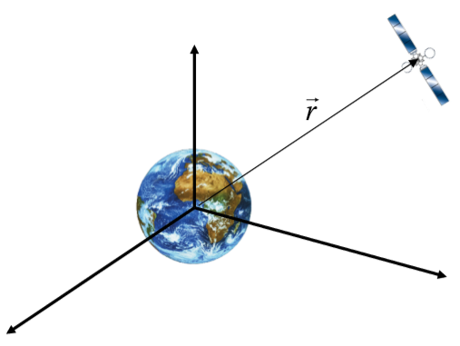What this implies is that **the center of mass of the two-body system is considered to be approximately the center of mass of the larger one**, so **the smaller object does not affect the motion of the larger one**
  + So you assume that the center of the larger object is fixed in inertial space, and you use it as the origin of an inertial reference
* *This is called the* ***restricted two-body problem***
* 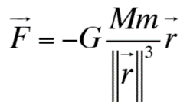Assume then that the reference frame has origin at the center of the larger object (here the Earth)
  + Then the force on the smaller object by the larger one is:
  + Again, we can bring Newton’s second law in:

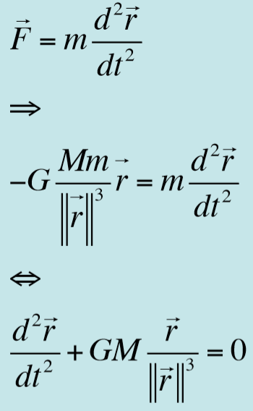

* + Which **is the equation of motion for the restricted two body problem**
* In this restricted context, we usually replace with **, which has a varying value for different objects**
  + I.e.

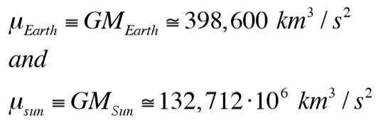

* So the final equation for restricted two body motion is:

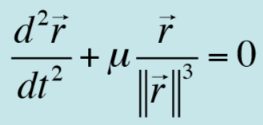

* Remember, though, that this is a differential equation in **vector form**, so **it actually represents 3 simultaneous *second-order nonlinea*r differential equations (in 3D cartesian space):**

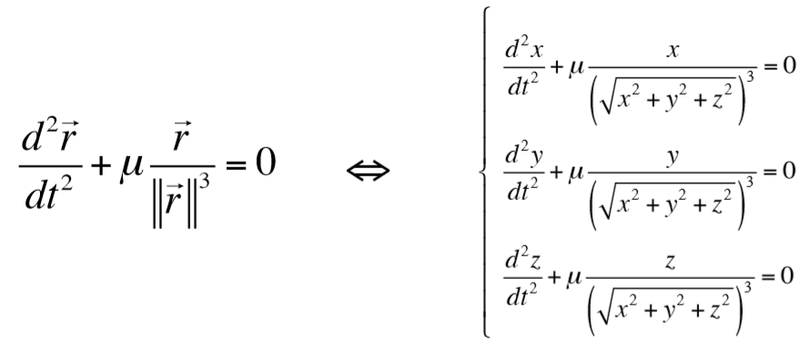

* How can we write it in polar coordinates?
  + Some notation:

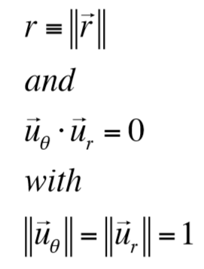

* + Recall from dynamics that, for position



* + For velocity:

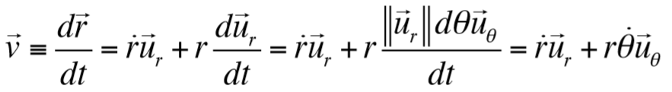

* + For acceleration:





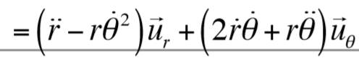

* Note that the acceleration term is in the restricted two body motion equation:

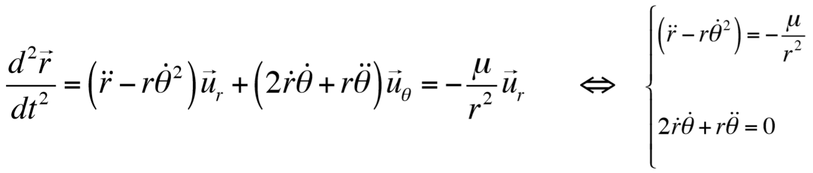

* + Note that this second equation can be written as:

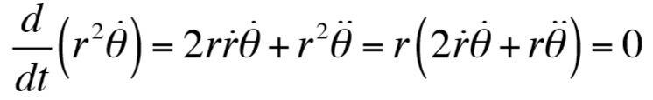

* + So those two equations are **the restricted two-body problem equations of motion in polar coordinates:**

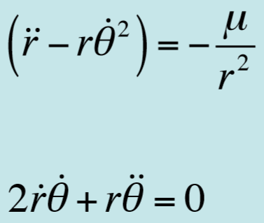 

### Integrals of The Restricted two-body Problem: Angular Momentum

* We break down/get more out of this equation

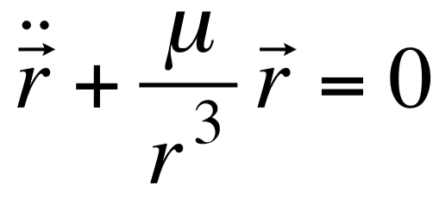

* + Start by taking the cross product by r:

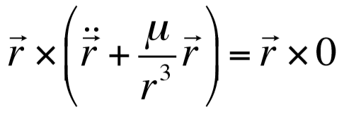

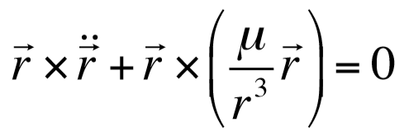

* + The second term is 0 (because cross product of the same vector) so you get:

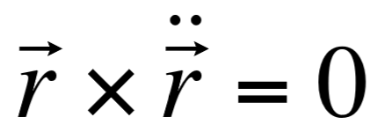

* + - Notice that you can write this as:
    - Since:
    - And that first term is 0
  + So basically:

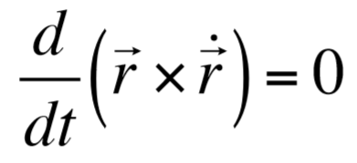

* When you integrate this equation:

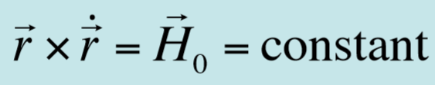

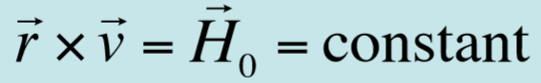

* The results implied by this are important, that equation basically states that **the angular momentum of the object along its trajectory is conserved:**
  1. This means that the position and velocity vectors are always in the same plane since their cross product is constant (remember that the cross product gives a vector perpendicular to both vectors, so if constant at all times then the two vectors move in the same plane at all times)
     + The normal to this plane is
     + “The initial conditions on the position velocity vectors will determine this plane, and the object will remain in this plane”
  2. **This cross product is the *massless angular momentum*** (angular momentum per unit mass)
     + The angular momentum of the object on its trajectory is conserved
* “What is the orientation of with respect to and :

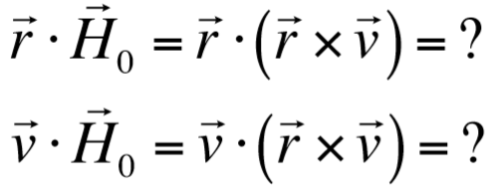

* + Hint: 
  + FOR YOU TO FIND OUT!
* In cylindrical coordinates:
  + Let be the unit vector orthogonal to and , then:

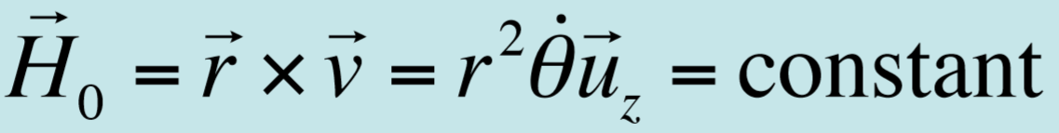

* What is a geometric interpretation of this term ?
  + The surface area dS covered by OAA’ is given by: :

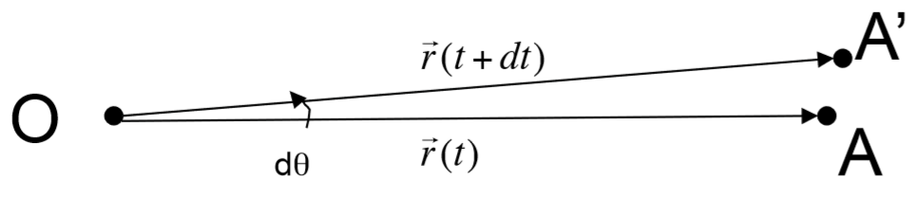

* + Taking the time derivative of both sides:

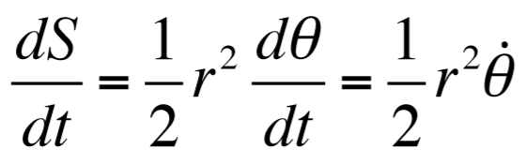

* + Which **means that the surface area covered by the object in orbit per unit time is constant**
  + **The position vector sweeps out a constant area per unit time**
* This was Kepler’s second law of planetary motion but there was no explanation for it until this
* Thus, the (constant) angular momentum is equal to twice the surface area swept by position vector:

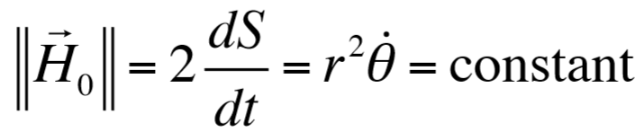

* Consider an object subject to a central (radial) force, regardless of its magnitude:
  + Thus:

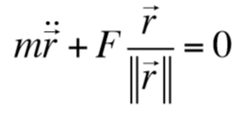

* + Take the cross product:

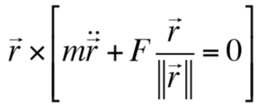

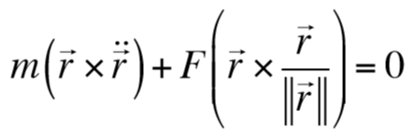

* + Thus:

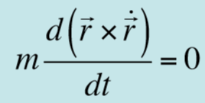

* So **the conservation of angular momentum is a feature and a result of the radial force**

### Integrals of the Restricted Two-Body Problem: Energy Integral

* What does all this even have to do with Energy?
* Going back to the equation of motion:

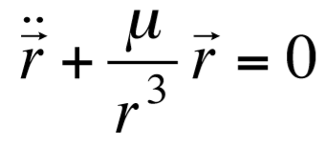

* + We can take the dot product:

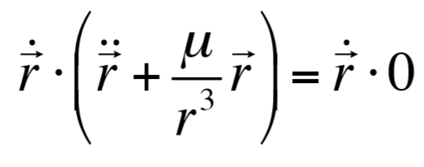

* + Distribute:

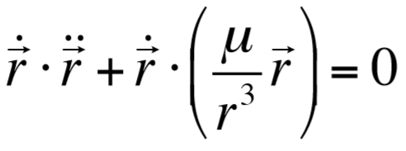

* We simplify the first term, note:

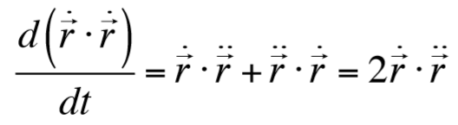

* + So the first term in the boxed equation can be rewritten as:

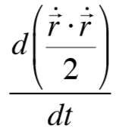

* + Or:

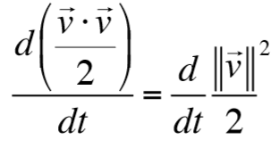

* We also simplify the second term, note:
  + “where is the radial velocity (component of the velocity vector projected on the position vector)”
  + Using that you can simplify the second term:

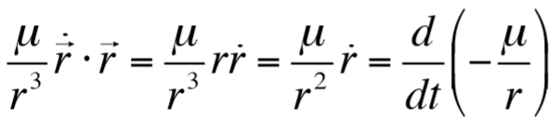

* So the boxed equation becomes:

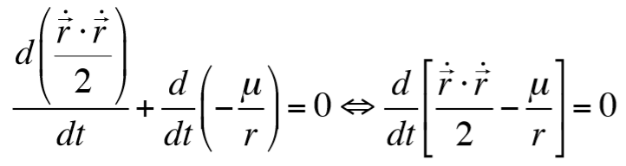



* + **The first term in brackets is the KE, the second is the PE**
  + We integrate this equation:

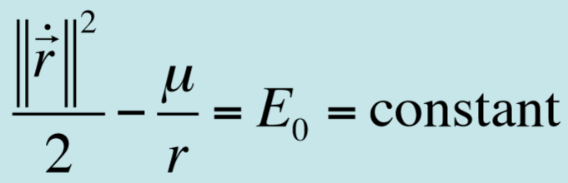

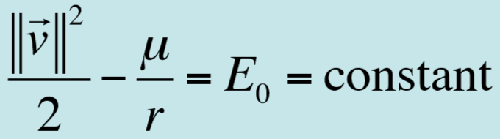

* + So **the total specific energy of the object is conserved (constant) along its trajectory (kinetic + potential)**
* This means that **the object in orbit, not subject to forces other than the central force analyzed, conserves the initial energy it was provided with**
  + The object will exchange KE for PE along the way and vice versa, but their sum remains constant
* There are other integrals of the equation of motion of the two-body problem
  + E.g. the eccentricity vector, which can be obtained by taking the cross product of the equation with the angular momentum vector
  + We can show that the eccentricity vector is constant
  + We don’t do any of that though

## Summary of Geometric Relationships for an Ellipse

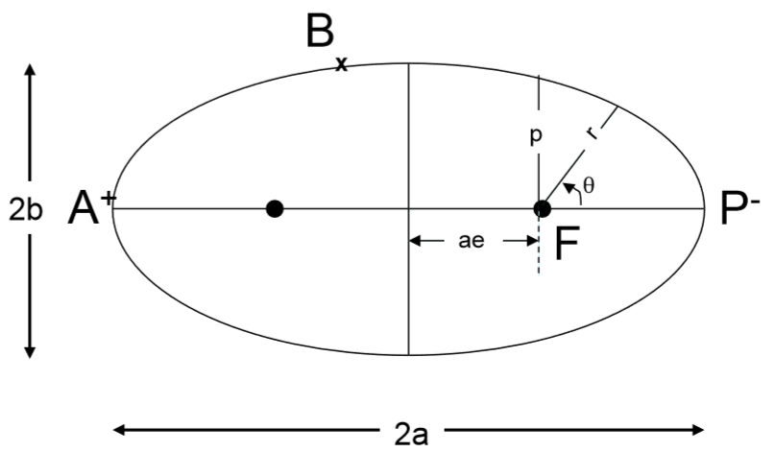

* I’m just going to show all the equation he gives about an ellipse:

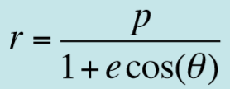

* + For an ellipse

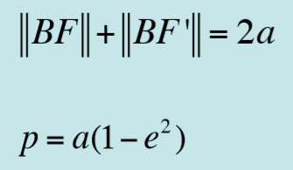

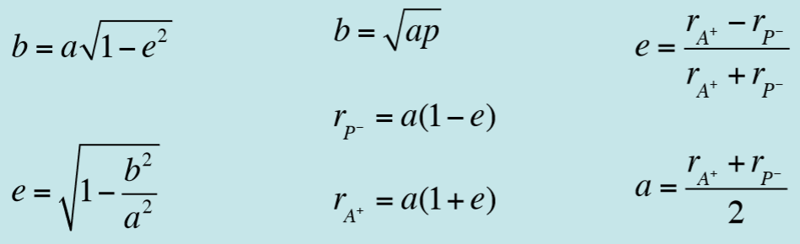

## Solution of the Restricted Two-Body Problem

* We go back to the two-body problem equation of motion (included below for reference) and find the actual solutions

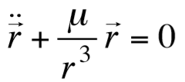

* So these equations are kind of just given:

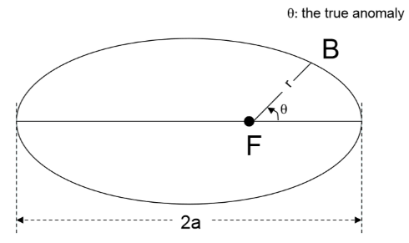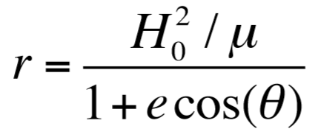 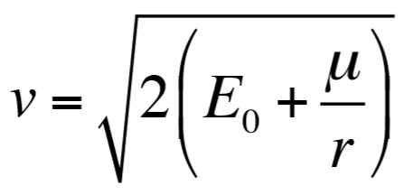

* + You can get the second equation directly from the one we got after the energy integral part
  + **The first equation is the “polar equation of a conic section”**
  + **r is bounded, the orbit is bounded by**
  + **The trajectory is unbounded if**
  + **is called the *true anomaly***
* “The first equation proves Kepler’s first law, that the orbit of an object in the restricted two-body problem is a conic section with the primary object located at one of the foci”
* “For an ellipse, we can show that:”

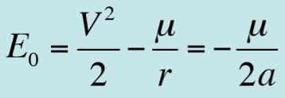 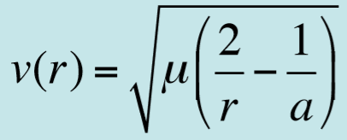

* + **The magnitude of the velocity vector changes on orbit as a function of the distance to the primary object**
  + Think about this in terms of r being large or small, if it’s small then v will be large, so if the object is closer, it will move fast

### Solution of the Restricted Two-Body Problem

* He just asks some questions

1. Calculate v at the perigee (nearest point to earth)
2. Calculate v at the apogee (farthest point from earth)
   * From before we have this equation:

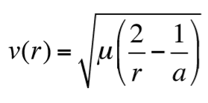

* + At the perigee we have:

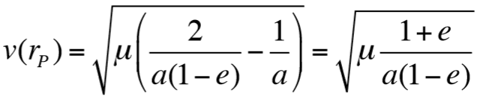

* + At the apogee we have:

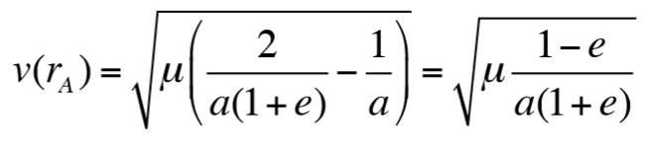

* + Clearly:

1. What is the angle between the position and velocity vectors at the perigee and apogee?
   * The magnitude of angular momentum is:
   * At the perigee and apogee, the position and velocity vectors are orthogonal:

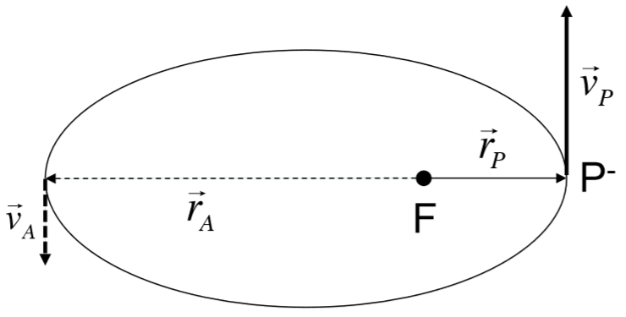

1. Calculate the (massless) angular momentum at the perigee. Redo the calculation at the apogee. What do you find?

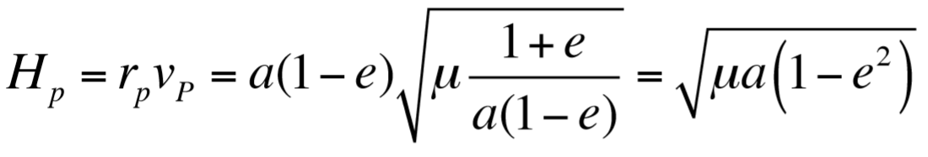

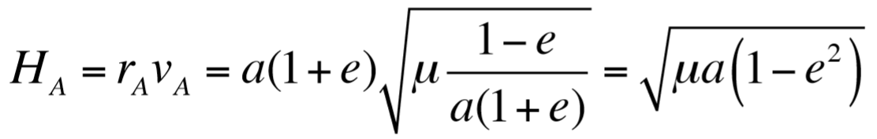

* + So you get that they’re the same, which we knew because angular momentum is conserved:

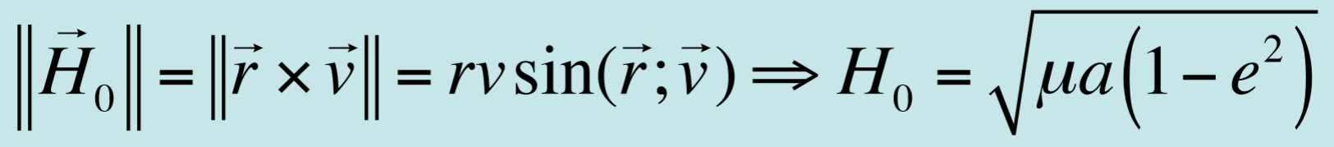

## What is the Period on Orbit?

* We saw that the surface swept by the position vector per unit time is constant:
  + To cover the whole surface of the ellipse, the object needs time T:

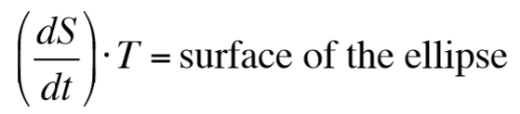

* + But by definition you know that the area of an ellipse is:

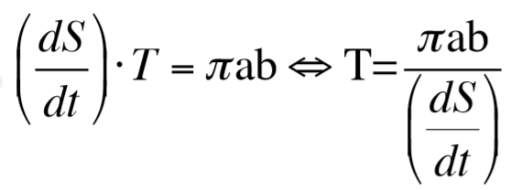

* + Recalling the red boxed equation we just derived, and that :

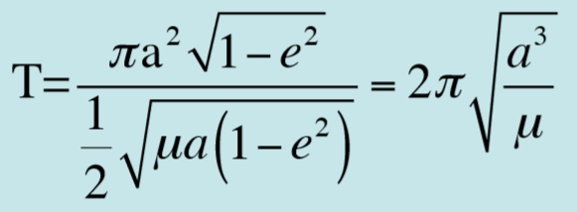

* Notice that the orbital period is independent of eccentricity

## Summary of Results for Elliptical Orbit

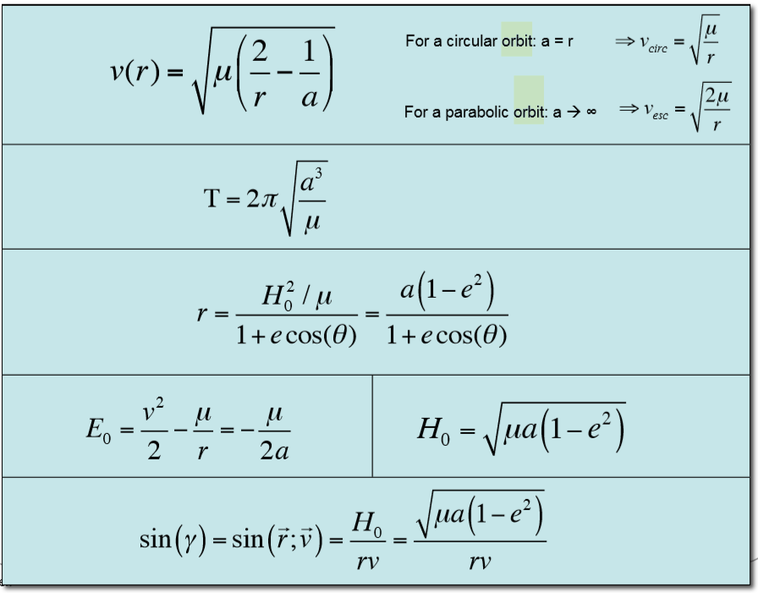

## Kepler’s Laws (+Historical Notes)

1. **Kepler’s first law:** The orbit of each planet is an ellipse, with the sun at one focus
2. **Kepler’s second law:** The line joining the sun and an orbiting planet (position vector) sweeps out equal areas in equal time
3. **Kepler’s third law:** The square of the period of the planet is proportional to the cube of the mean distance to the sun

## What about a Circular Orbit?

* If the orbit is circular, , and
* “If at orbit insertion or initial conditions we have:
  + And (since for a circular orbit a is equal to r, because r is constant so there is non semi major axis):

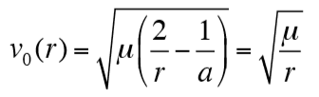

* + Then you get a circular orbit
* For a circular orbit, the orbital velocity and orbital period are thus:

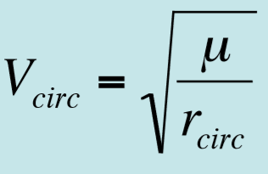 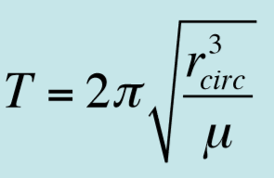

* We now look into the position and velocity vector’s angles
  + We know that the radius of the orbit is constant:
  + We also know that the dot product of a vector times itself is 1, so (but why not just write the thing below as 1?):
  + So the derivative of that must be 0:
  + More explicitly, the derivative of the term in parenthesis is:
  + So, since dot product is commutative:
  + **So the position vector and velocity vector on a circular orbit are always orthogonal**

## Reminder: Watch out for “Altitude” versus “Radius”

* Altitude, , is measured above the surface of the earth:
* 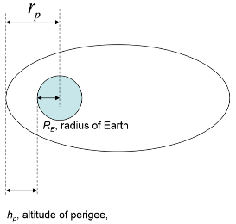The same applies at perigee and apogee, for perigee:

## Escape Velocity

* We saw previously the velocities for an elliptical and circular orbit (read over them if you forgot)
* What about a parabolic orbit? What velocity do you need to get that?
  + A parabolic orbit means the secondary objects escapes the gravity attraction of the primary object and goes to infinity
* There are two ways of computing the escape velocity:
  + For a parabolic orbit: , and , so:

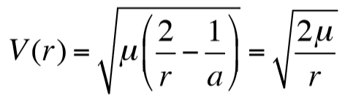

* + Or we can make an energy argument. We saw previously that the specific energy is conserved (“and is negative for bounded orbits”). “If an object can reach infinity with zero velocity”:

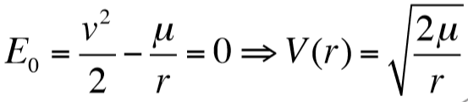

* So the (minimum) escape velocity:

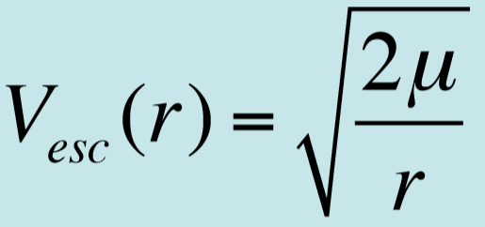

### Orbital Velocities and the Type of Orbits

* This is just a quick summary of the velocities for each type of orbit:
  + Circular velocity:
  + Elliptical velocity:
  + Parabolic velocity (If the object is given ), it will “escape” the Earth gravitational field

### Table of Interesting Information

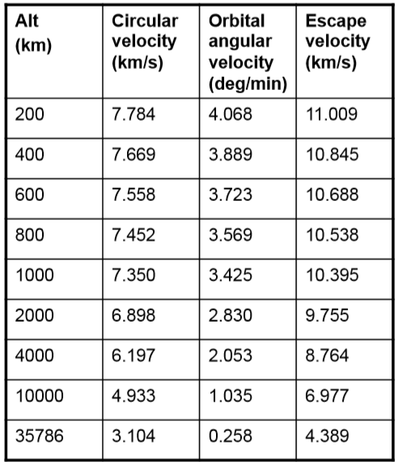

## Flight-Direction Angle

* 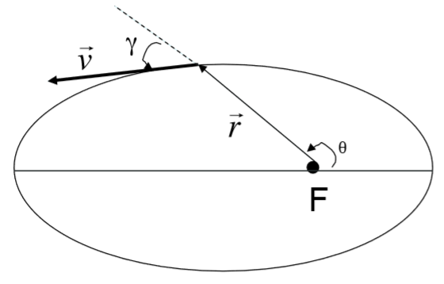The angle between the position vector and the velocity vector is the **flight-direction angle** (not the flight-path angle
* They pose a problem: Say you have two orbits around a body and , that intersect at the position vector
  + When the spacecraft on O1 is at this intersection point…
  + To be on O2 at this intersection point, a spacecraft needs a velocity vector …
  + Sketch…
  + **How do you think you can make the spacecraft on O1 at the intersection point go to O2**
    - You need a vector that takes you from to
* Some more questions:
  1. What is on a circular orbit?
     + 90 degrees?
  2. What is at the perigee on an elliptical orbit? At the apogee?
     + 90 degrees?
  3. What is anywhere between the “apogee and apogee”? How would you calculate it?

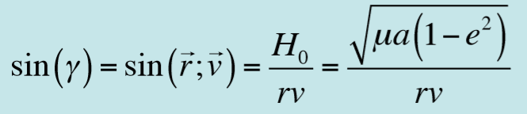

* + - 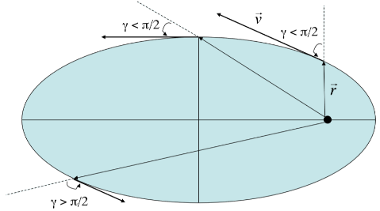How is the sine equal to that?
    - As the object moves from the periapsis to the apoapsis, r increases, so you have a positive *radial velocity* (velocity towards the orbiting object, as opposed to the tangential velocity) along the position vector:
    - Conversely as the object moves away from the apoapsis to the periapsis, r decreases and we have a negative radial velocity along the position vector:
* Then you can substitute the v equation into the sin equation we just (somehow) derived:

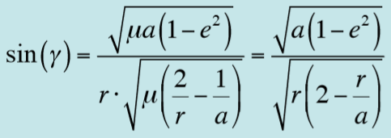

* + So if we know r, we immediately know the sine of the flight direction angle on a Keplerian orbit

# 3. Introduction to Keplerian Orbits and the Two-Body Problem (Part 2)

## A Taste of Kepler’s Equation

* Notice that, though we derived many results from two-body problem equation of motion (e.g. the equations under “Summary of results for elliptical orbits”, we don’t actually have any solutions with respect to time
  + Such as , , or
  + So we don’t have solutions for true anomaly or velocity with respect to time
* For example, imagine you have a spacecraft in elliptical orbit with and
  + At the spacecraft is at perigee
  + Determine the position at minutes, minutes, etc.
  + Determine the time for the spacecraft to reach away from the perigee
* This is like asking to find the position or time taken for the spacecraft to reach a certain position or true anomaly
* We don’t actually go over how to solve for this, but here’s a glimpse:
  + M is the **mean anomaly**
  + 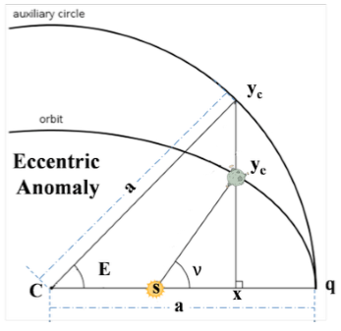E is the **eccentric anomaly**

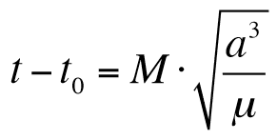

* + Where

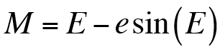

* + Note also that:

and

* The equation is known as **Kepler’s equation**
  + It is transcendental in E: has no closed form solution and the solution can’t be expressed in a finite number of terms
  + So we need Fourier series, power series, or Bessel functions
  + We use numerical methods in general

## Spacecraft Orbits and the Classical Orbital Elements

* Here we look at how to **completely** describe an orbit in space (knowing how to describe the ellipse doesn’t tell you enough about it)
* Remember that the two-body problem equation below is a **six-degree of freedom dynamical problem**
  + The orbit is completely defined by 6 initial conditions for the position and velocity vectors
  + So **we need six parameters to specify the orbit**

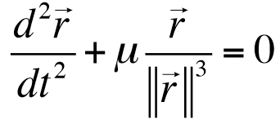

* The six orbital elements are:
  1. The **semi major axis** of an ellipse**: *a***
  2. **Eccentricity: *e***
  3. **Inclination:** ***i***, the angle between the equatorial plane and the orbital plane
     + *To know the direction of rotation*, you just *look at the angular momentum vector* (since it’s orthogonal to the orbital plane and is the cross product of the position and velocity vector)
  4. **Right ascension of the ascending node:**
  5. **Argument of the perigee:**
  6. The **true anomaly:**  (“the time since perigee passage”)
* The first two are self-explanatory, I break down Dr. Saleh’s notes with additional explanations, including from class

### Inclination

* The inclination is the angle between the equatorial plane and the orbital plane
  + A **polar orbit** is one that has a 90o inclination, it goes over the poles
* **The inclination is also the angle between the vector pointing to the North pole and the specific angular momentum**
  + Since those two vectors are perpendicular to the equatorial and orbital planes respectively
* We write it as:
* 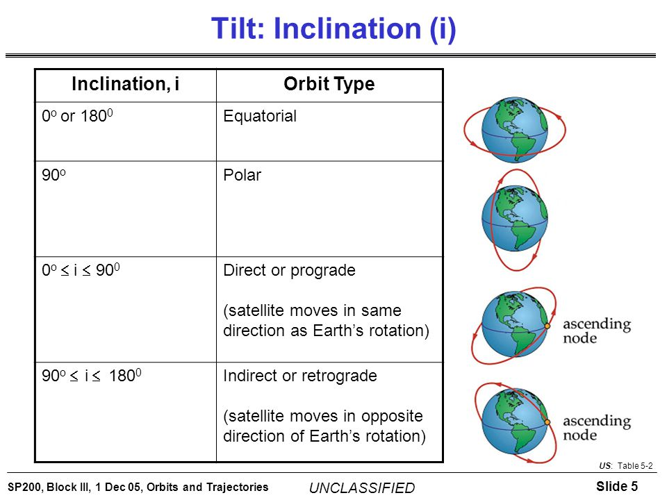For example, a 45 degree inclination:

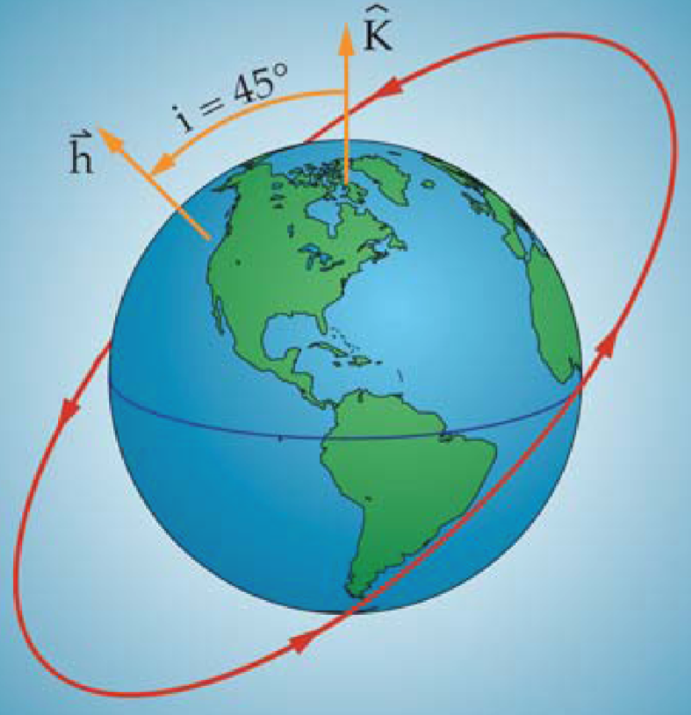

* Thus, we can define different types of orbits:
  + **Equatorial orbit:**
  + **Polar orbit** (goes over North and South Poles)**:**
  + **Prograde orbit** (it moves with the Earth’s rotation eastward)**:**
  + **Retrograde orbit** (moves opposite the Earth’s rotation westward):
* Think about the use of the north pole and momentum vectors to define *i* though, clearly there can be many such orbits

### Right Ascension of the Ascending Node

* 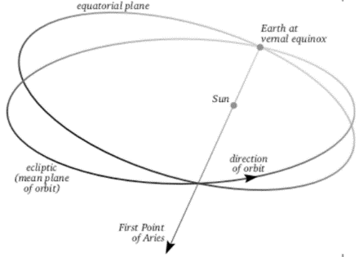To define this we need an inertial direction to our frame (a direction that doesn’t rotate with the earth)
* We need a way to define such a direction
  + We use the intersection of the ecliptic plane (the mean plane of the apparent orbit of the Sun as seen from Earth) and the equatorial plane
  + During the first day of Spring in the Northern hemisphere, the **vernal equinox**, this intersection gives us that inertial direction
  + We use the vernal axis at a given epoch, right now we use the one from 2000, which is called **J2000**
* Note that the earth equatorial plane is at about 23o with respect to the ecliptic
* Anyway, we align our axis with this intersection
* Now, the orbital plane (of the satellite as usual) will intersect the equatorial plane at two points
  + The line crossing these two points is **line of nodes**
  + 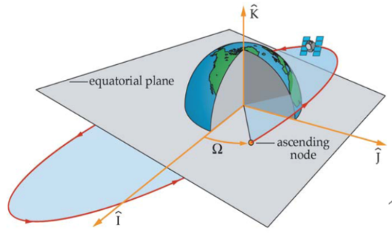One is when the satellite is going from the south of the equatorial plane to the north, the **ascending node**
  + The other one is the **descending node**
* **The right ascenscion of the ascending node, , is the angle between the inertial direction and the line of nodes, pointing towards the ascending node**
  + Measured counterclockwise in the equatorial plane

### Argument of the Perigee

* Ok cool, but now where is the perigee? It could be anywhere along that orbit
* 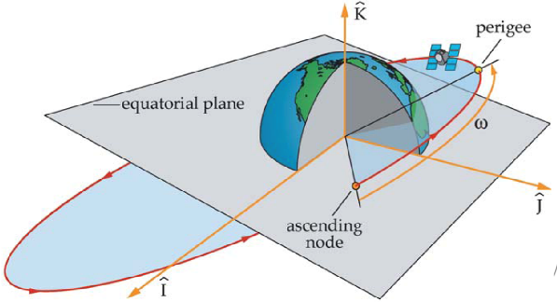The angle from the ascending node (of that satellite) to its perigee is the **argument of the perigee,** 
  + Measured in the orbital plane, in the direction of motion

### True Anomaly

* The true anomaly is the “time since perigee passage”, which you can solve for using Kepler’s equation
* I think it’s the angle between the perigee and the satellite along the orbit
* **This is the only non-constant value among the 6 orbital elements**

### QUESTIONS

* First, he asks us to sketch out three different orbits as defined on slide 25
* For an orbit with an argument of the perigee ω, what is the true anomaly of the spacecraft when it is at the ascending node? At the descending node? (My answers/guesses below)
  + At ascending node:
  + At descending node:
* What is(are) the argument of the perigee for an orbit whose line of apsis is also its line of nodes?
  + (because the perigee is now along the line of nodes, from which is measured)
* **From class (Test question):** Why not use the semi-major axis to define angle 4? (Hint: it’s in 5’s definition)
  + Because then you wouldn’t be able to define an *argument of the perigee*, meaning that your perigee would always be defined as being along the line of nodes. Essentially, if you used angle 4 to denote the angle between the inertial direction and the ascending node (or line of nodes rather), then your ascending node would always be the perigee!

## Spacecraft Orbits

* Some earth orbits:
  + **Low Earth Orbit (LEO)**
    - Altitudes of the perigee and and apogee up to 2000km
    - Polar orbits are a subset of those
  + **Medium Earth Orbit (MEO)**
    - Near circular with altitudes of apogee and perigee around 20000km
  + **Highly Elliptical Orbits (HEO)**
    - Eccentric elliptical orbits that don’t fall into the other categories (e.g. Molniya orbit)
  + **Geostationary Earth Orbit (GEO)**
    - Altitude 35,786km, inclination 0
    - Unlike the others, there is only one geostationary orbit
* There are also **Geostationary and Geosynchronous *Transfer* Orbits (GTO)**
* Some examples:

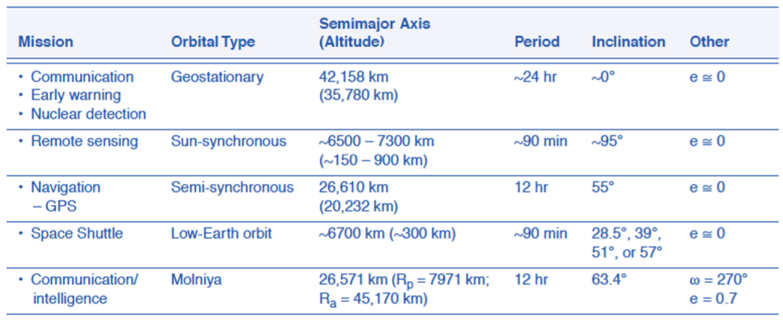

## Satellite Ground Tracks

* A spacecraft ground track is the projection of the orbit on the surface of the object it is orbiting
* It is the location of the intersection of the spacecraft position vector with the surface of the object as the spacecraft orbits it
* 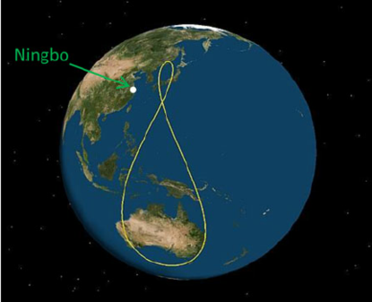Examples:

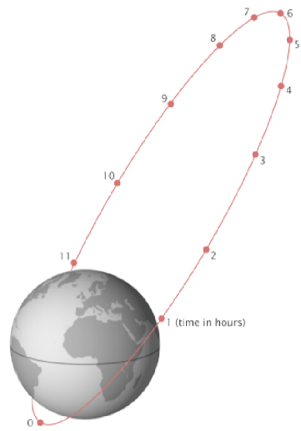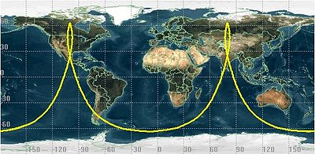

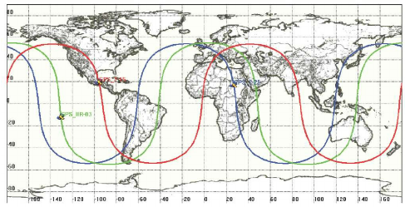

* The shape of the ground track will depend on and reflect some of the orbital parameters
* For **inclination:**
  + 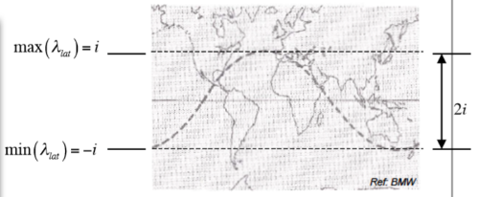For a direct (posigrade) orbit, , the latitude of the ground track is bounded by the orbit inclination

* + For an indirect (retrograde) orbit, , the latitude of the ground track is bounded

* 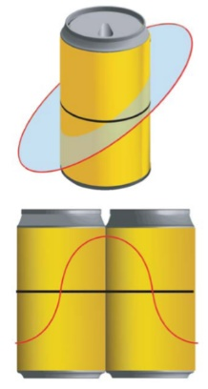Next we consider the orbital period, if we measure the ground tracks, we can deduce the **semi-major axis**
  + Take a satellite in prograde low earth orbit, imagine that it travels faster than the earth
  + Imagine that the earth doesn’t rotate, then the ground tracks remain constant and repeat every orbit
  + However, as the earth rotates, the ground tracks will shift West (since the earth rotates to the East)
  + Consider intersection of the ground tracks with the equator
  + **For two successive orbits, the angular distance between two successive intersections is the *node displacement***
    - 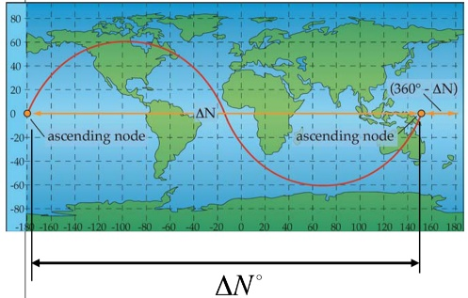I think is the distance between the first node equatorial crossing and the second, but counted towards the west:
  + By the time the spacecraft completes one orbit, the Earth rotated by
  + By measuring , since we know the Earth angular rotation, we can deduce the orbital period
    - 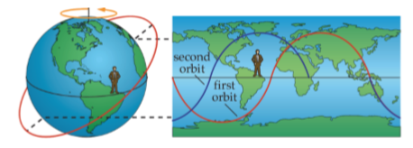**The earth angular rotation:**

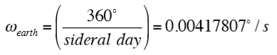

* + So the orbital period for a direct (prograde) orbit is:

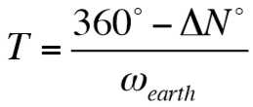

* + Since we also know that the period is , we deduce that:

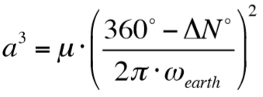

* + As decreases, the ground tracks get compressed, increases
    - *Larger period*smean the spacecraft is *slower*, so the semi major axis is greater

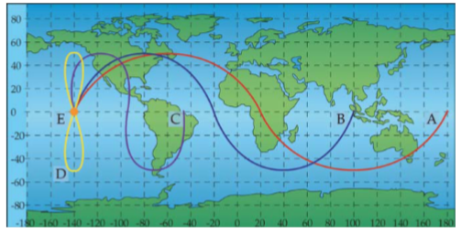

* + In the image above: , and
  + What if ? Then, if you do the math , which is the *geostationary orbit radius*
  + **Test question:** What if ? That would mean that you instantaneously flew around the earth and ended up in the same spot even before the earth rotated. This is clearly impossible but, more specifically, the maximum velocity you could reach would be at the surface of the earth, which defines your max
* Finally, for the **eccentricity**:
  + 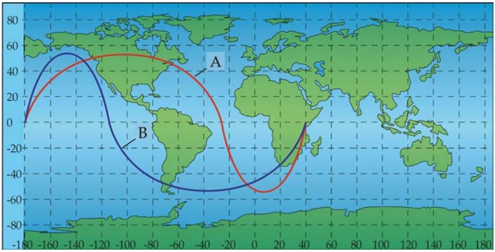If the ground tracks above and below the equator are not symmetric (with respect to a node), then there is an eccentricity
  + Consider the image to the right
  + We don’t define explicit equations for figuring this out but just get some heuristics instead:
    - Spacecraft move fastest at their perigee so the tracks are spread out there
    - Spacecraft move slowest at their perigee so tracks are crunched there
    - If the ground tracks become retrograde, that happens in the vicinity of the apogee
  + E.g. in the figure above:
    - How does the period of A compare with the period of B?
      * The same
    - Where is the apogee of orbit A? (Northern or southern hemisphere)
      * Northern hemisphere
    - Where is the apogee of orbit B?
      * Southern hemisphere

## Complications to Keplerian Orbits: A Brief Introduction to Orbital Perturbations

…

# 5. Introduction to Orbital Maneuvers and Transfer (within the two-body context)

## The Idea of Orbital Maneuvers

* We saw that once a spacecraft is placed on orbit, it stays on that orbit
  + The initial orbit insertion conditions (on the position and velocity vectors, including the flight direction) determine the entire orbit (minus orbit perturbations)
  + Pretty much, given and , the and are determined for all

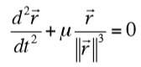

* If we have a rocket engine on-board, we can use its thrust to modify the spacecraft velocity vector at some point on the orbit, e.g. at we can get:
  + Instead of
  + This results in a new orbit
  + Mathematically, this is like having initial conditions for the two-body problem at
  + **This is called an orbital maneuver, or orbital transfer (transfer from one orbit to another)**

## Single Impulse Maneuver

* **Impulsive maneuvers:** The engine delivers high thrust and the burn-time and resulting velocity increment occur in a very short period
* The velocity change is considered to have occurred instantaneously
  + Right before the maneuver, at , the velocity is:
  + Right after the maneuver, at :, the velocity becomes:
  + With
* 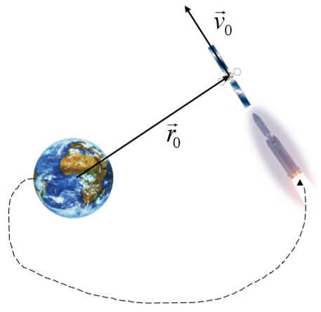This approximation is not appropriate for electric propulsion, which thrust continuously to slowly accelerate the vehicle
* The situation is the following:
  + A launch vehicle injects a spacecraft at with a velocity at (already in orbit I guess from the picture?)
  + The two vectors are orthogonal at :
  + *What will the new spacecraft orbit be?*
  + *Determine its shape and parameters*
* The initial conditions provide the specific energy and angular momentum:

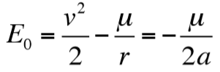 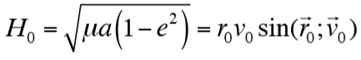

* + For example, consider that and , then using the equations above:

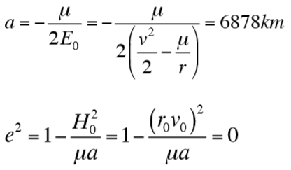

* + If you actually do the math and substitute the value you’ll see that this is correct
* **Note**  that we could also have figured out that this orbit is circular by noticing that, for the values given:
* Now imagine that at some point on this circular orbit, an impulse is delivered and changes the velocity to:
  + *What will the new orbit be?*

1. **Note:** Dr. Saleh doesn’t follow any book, **this is all from his lecture/class notes.**